|  |  |
| --- | --- |
| **Practicum Case** |  |
| CPEN6098 | CPEN6108 | CPEN6109  Computer Networks |
| **Computer Engineering** | **O1-CPEN6098-EG01** |
| ***Valid on*** *Even Semester Year 2018/2019* | **Revision 00** |

## Learning Outcomes

* Explain concepts of create network environment

## Topic

* Session 10 - Internetworking

## Sub Topics

* Basic Mikrotik Configuration
* Basic Configuration
* IP Address List
* DNS
* NAT

## Soal

*Case*

**Mikrotik Introduction**

Nowadays, Mikrotik is commonly used in ISP, hotspot provider, or internet cafe owner. Mikrotik OS makes the computer as router network that equipped with any feature and tool, for both wired network and wireless.

In this tutorial, the writer gives explanation and simple guides on Mikrotik configuration for some and general purposes that usually needed for internet cafe server/router or others network, that configuration can be for NAT server, Bridging, etc.

**Mikrotik Access:**

1. via console

Mikrotik router board or PC can be accessed directly via console / shell or remote access using putty.

1. via winbox

Mikrotik can be accessed/remote using software tool winbox.

1. via web

Mikrotik can be accessed via web/port 80 by using browser.

Topology scenario in Lab Software:

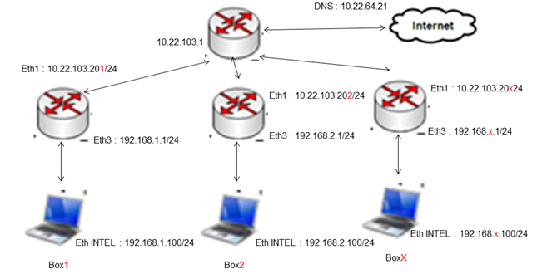

**Basic Mikrotik Configuration**

**Accessing router using winbox.exe:**

1. Run the winbox.exe program

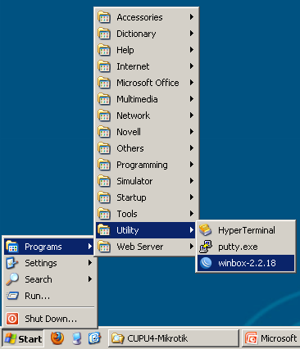

1. Connect with router that will be configured

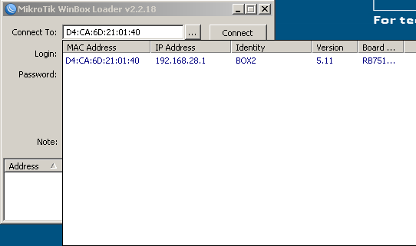

1. Login with

* *user* : prk
* *password* : prk

Then click ***connect***.

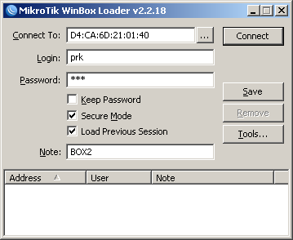

klik

1. After connected with the router

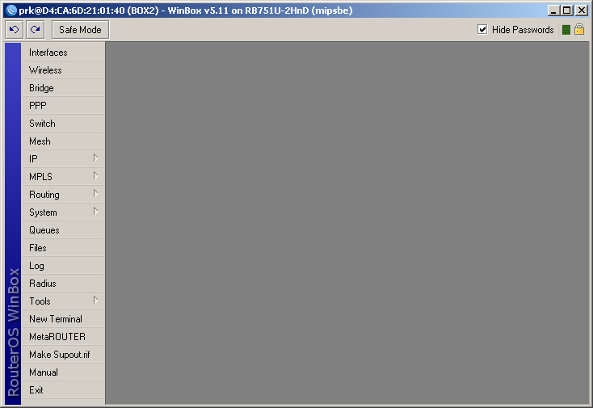

**Set / Change Mikrotik name:**

1. Choose the tab System 🡪 Identity

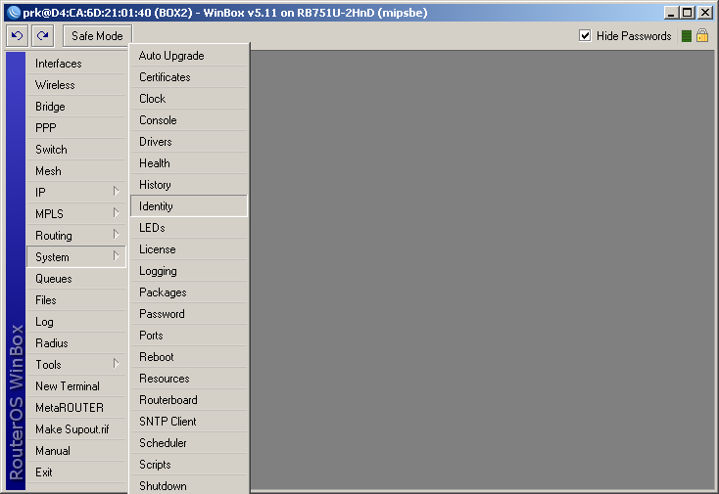

1. Change the router identity name with your custom name

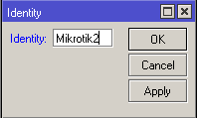

1. After that, choose OK and router identity already changed



**IP Address Setting:**

1. Via terminal (CLI)

**[prk@Mikrotik2] > ip address add**

**address: 10.22.103.202/24**

**interface: ether1**

**[prk@Mikrotik2] > ip address add**

**address: 192.168.2.1/24**

**interface: ether3**

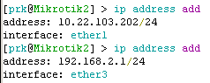

1. Via winbox

* Choose tab IP 🡪 Addresses

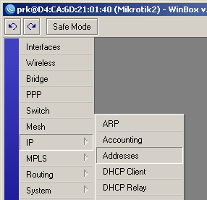

* Choose add button ( sign : plus )

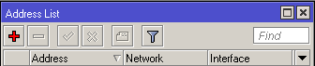

* Then, fill with custom IP Address

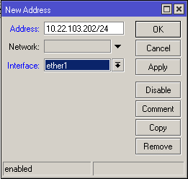

* If already filled, will be displayed as follow

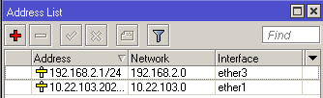

**Gateway Setting:**

1. Via Terminal (CLI)

[prk@Mikrotik2] > ip route add gateway=10.22.103.1



1. Via winbox

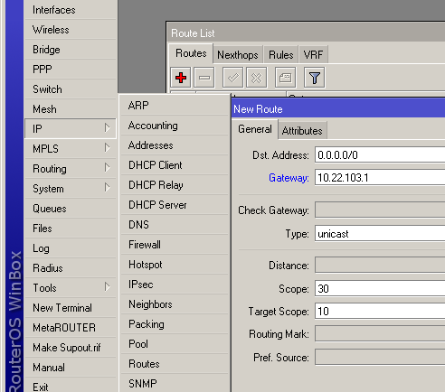

**DNS Setting:**

1. Via Terminal (CLI)

[prk@Mikrotik2] > ip dns set servers=10.22.64.21 allow-remote-requests=yes



1. Via winbox

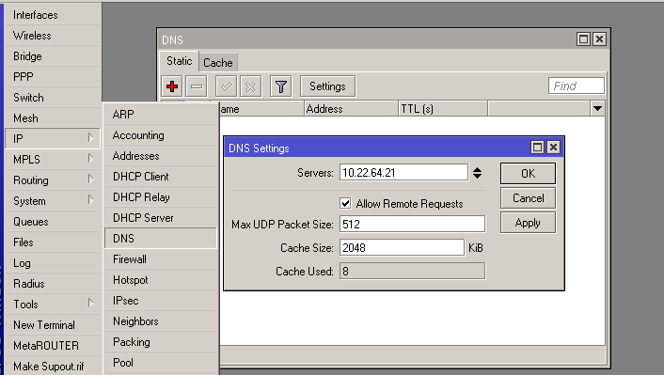

**Mikrotik as NAT**

**Network Address Translation** or **NAT** is a method to connect more than one computer to internet network by using one IP address. The many usage of this method is due to the limited availability of IP addresses, security requirements, ease and flexibility in network administration.

IP protocol that is widely used is IP version 4 (IPv4). With the length of address of 4 bytes, that means 2 to the power of 32 (232) = 4.294.967.296 available IP address. Theoritically, these are the number of computer that can directly connect to the internet. Because of this limitation, many ISP (Internet Service Provider) only allocated one address for one user and this address is dynamic, that means the given IP address will be different everytime user connected to the internet.

This will make it difficult for the lower-middle class of business. On one hand, they need some computers that connected to the internet, but on the other hand there is only a single IP address, which means there is only one computer can connect to the internet. This condition can be solved by using NAT method. With NAT gateway that run in one of computer, that one IP address can be shared with some other computers and they can connect to the internet at same time.

Example, we want to hide the local network / LAN 192.168.2.0/24 behind one IP address 10.22.103.202 that is given by ISP, we will use Mikrotik feature, specifically source network address translation (**masquerading**) . **Masquerading** will changes source IP address data packets and port from network 192.168.2.0/24 to 10.22.103.202, then forward the packet to global internet network.

**NAT Setting:**

1. Via Terminal (CLI)

[prk@Mikrotik2] > ip firewall nat add chain=srcnat out-interface=ether1 action=masquerade



1. Via winbox

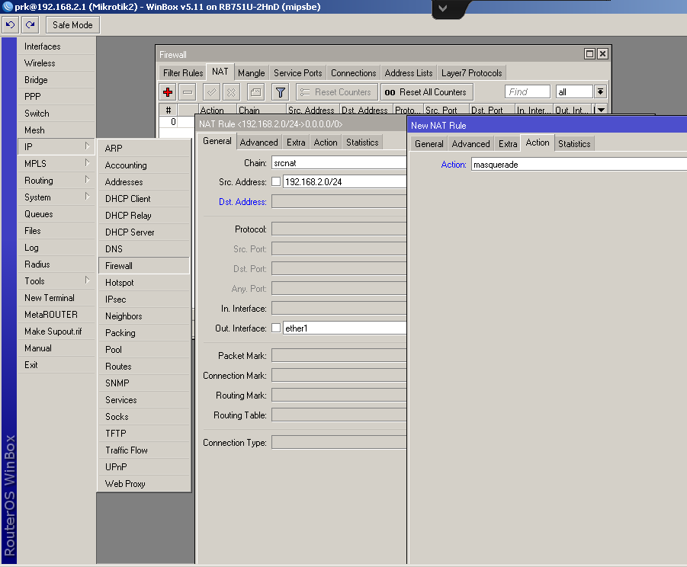

**Steps for NTP setting:**

1. Via Terminal (CLI)

[prk@Mikrotik2] > system ntp client set primary-ntp=103.12.12.14 enable=yes



1. Via winbox

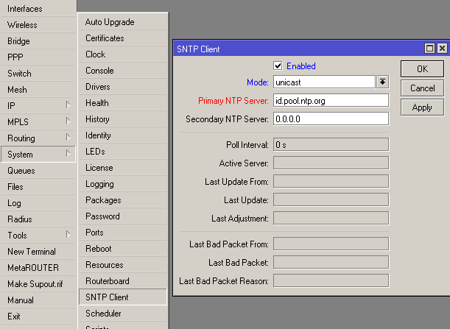

**Backup Configuration :**

1. Via Terminal (CLI)

[ast@Mikrotik2] > system backup save name=Backup1

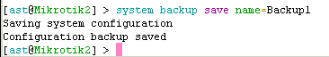

1. Via winbox

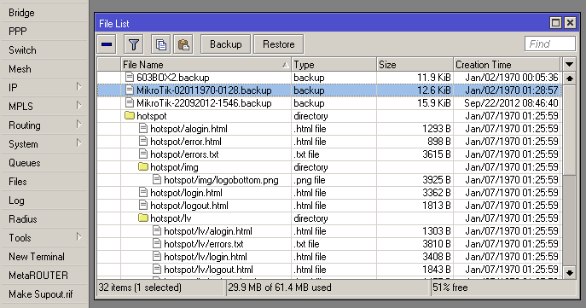

**Restore configuration :**

1. Via Terminal (CLI)

[ast@Mikrotik2] > system backup load name=Backup1

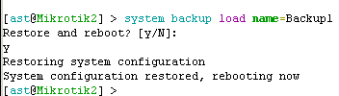

1. Via winbox



**IP Address Setting on PC:**

1. Windows run : ncpa.cpl

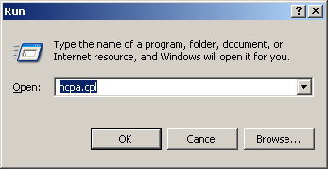

1. Choose LAN2 🡪 Properties

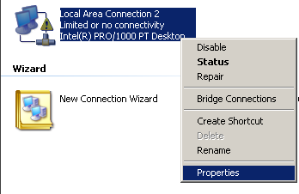

1. Choose tab General 🡪 Internet Protocol(TCP/IP)

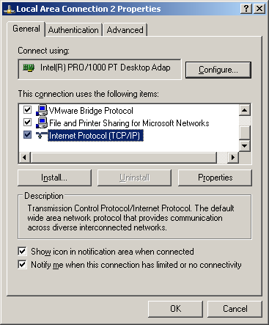

1. Setting IP Address on your PC

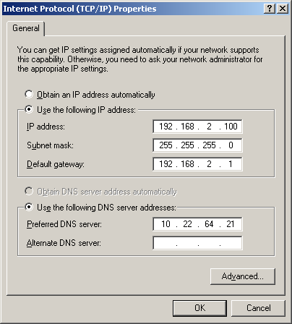

1. Your PC dan Router already connected

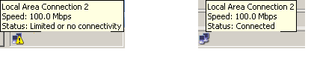

**If you don’t understand, please ask to your assistant!**